Evaluating Conversation Behaviors
One of the lessons that every student needs to learn is that there is a clear difference between collaborative and competitive dialogue (Copeland, 2005). While competitive dialogue has a place in our world – we all need to be persuasive at times – collaborative dialogue is often more productive. People engaged in collaborative dialogue see one another as learning partners instead of opponents– members of the same team exploring topics together. They value one another’s contributions even when they disagree. Use this handout to learn more about collaborative dialogue.
Evaluating Conversation Behaviors
In a 2011 debate sponsored by CNN, Mitt Romney and Rick Perry – two presidential candidates – got into an argument with one another about what America should do about immigrants who come to our country illegally. Watch their exchange (http://bit.ly/romneyperrycnn). While watching, check off each of the terms in the checklist below that accurately describes the candidates’ conversation behaviors.
- The candidates see one another as equals, learning together.  - The candidates respect one another’s viewpoints.  - The candidates do more listening than they do speaking.  - The candidates disagree agreeably.  - The candidates seem open to changing their own thinking.  - The candidates use questions to challenge one another.  - I think these candidates would make great partners. | - The candidates seem to be competing with one another.  - The candidates see one another as opponents to be defeated.  - The candidates are convinced that their own thinking is right.  - The candidates spend more time talking than listening.  - The candidates seem unwilling to consider each other’s ideas.  - The candidates try to prove that their partners are wrong.  - I can’t imagine these candidates ever working together.
Reflection Questions | Your Response
If you were to rate this conversation on a scale of one to five – with five representing a productive, healthy discussion and one representing a complete disaster – what rating would you give it? Explain your thinking.

Would the candidates agree with your rating? How do you think they would explain their behaviors in this conversation? Is there any excuse for acting this way in a conversation with someone that you disagree with? Is there any explanation for the kinds of conversation behaviors that these candidates demonstrate?

What was the most disturbing thing about this conversation to you? What bothered you the most? Was one candidate more “to blame” for the flaws in the conversation than the other, or were they equally at fault?

Was there anything about this conversation that we can admire?

Now, let’s look at a different conversation. In this strand from an online classroom conversation, a group of sixth grade students talk about the causes of hate in our world. Use this handout to rate their interactions.
Quote that sparked this conversation
Scoring 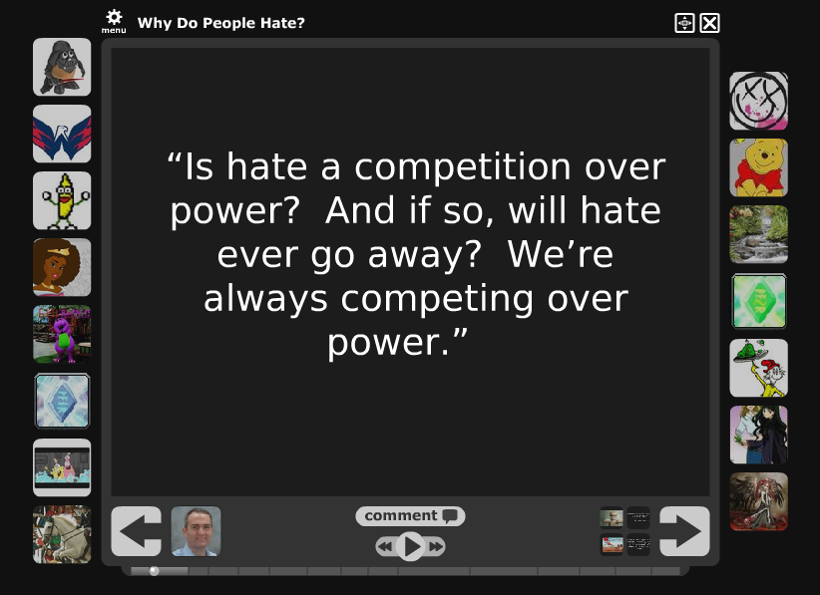
Student Conversation
Darth Tater: Here’s an interesting quote on hatred that came from a seminar on hatred in my classroom. What do you think the connections are between hatred and power? Do hatred and and a quest for power go hand in hand?
Evil Barney: I think that the quest for power just sets the stage for hatred to occur. Whenever I play the game Risk, I notice that I become frustrated with other players that stop my conquest. I bet when people are trying to gain power on a large scale in real life, that frustration builds up like lava in a volcano and comes out as violence and hate all at once.

I don't think power is completely to blame for hatred, but it definitely helps hatred come along. What else do you think power does for hatred?
Mearan: Hate, most of the time, is competing over power. For example, you are nominated for president. Then, another candidate wins the election. You aren’t going to be very happy are you? You will end up generating hate to that person, even if it is only a small bit.

Now, hate cannot be stopped, for it is a natural human emotion. As I have said before “we could create the illusion of it disappearing, but it will never be true.” Saying that, we could lessen people’s will to be in a higher power. It could lessen the hate, but it would never go away. Is there anyway to eliminate the humans need to be at the top of power?
The Happy Man: Mearan said: Is there anyway to eliminate the humans need to be at the top of power?
My answer is that there really isn't. The only thing we can do is to either get rid of that power, or to make power a little less glamorous. Most likely neither of those things is going to happen. The most anyone can do is wait for something to happen that does eliminate that need.

But in the grand scheme of things is there really any need for one person to have all that power?
Pooh Bear: Evil Barney said: “I think that the quest for power just sets the stage for hatred to occur.”
This really grabs my attention. Everyone keeps on saying that hate is expressed because of power. But what Evil Barney says is that power is kind of a step up to get to hatred. It leads to hatred…

When you feel power or the more you want it, it forces your hate to come out even stronger. A lot of the time in life, for some reason, people want to be powerful. I don’t understand. What is the significance of this? Why is control such an exciting word to people?

It’s kind of like and evil scientist or somebody in a movie. You might gain something so great, and so wanted by other people that it can get out of hand. By people wanting that thing (power) so much, you feel hate against them because they want the power that you have and you don’t want to be taken away.

So I guess my overall question is: Why do people love the feeling of power and control?
Mearan: Evil Barney said: “I think that the quest for power just sets the stage for hatred to occur,” and Pooh Bear said: “Power is kind of a step up to get to hatred. It leads to hatred.”

I somewhat agree with this. However, I see power as more of a fuel. Let’s think of hate as fire. The more the quest for power occurs, the more fuel you will have. So, if you have lots of fuel and then light the flames hatred, the flame will be big. Depending on the amount of fuel you had at the start, the flames of hatred will last longer, or it will be bigger.

So a quick clap for your new way of thinking. Anyone else see this from a different viewpoint?

Your Reflections
Begin by checking off each of the comments below that best describe the students’ conversation behaviors:
- The students see one another as equals, learning together.  - The students respect one another’s viewpoints.  - The students do more listening than they do speaking.  - The students disagree agreeably.  - The students seem open to changing their own thinking.  - The students use questions to challenge one another.  - I think these students would make great partners. | - The students seem to be competing with one another.  - The students see one another as opponents to be defeated.  - The students are convinced that their own thinking is right.  - The students spend more time talking than listening.  - The students seem unwilling to consider each other’s ideas.  - The students try to prove that their partners are wrong.  - I can’t imagine these students ever working together.
Questions to Consider | Your Response
If you were to rate this conversation on a scale of one to five – with five representing a productive, healthy discussion and one representing a complete disaster – what rating would you give it? Explain your thinking.

If you were to rank the comments in this conversation in order from the most important to the least important, what would your rankings look like? Why?

Which participant do you think made the most significant contributions to this sample strand of comments? Which made the least significant contributions? Explain your thinking.

If you were to change anything about this conversation, what would it be? How would your change improve the overall quality of the conversation between the students?

