Using Voicethread to Communicate and Collaborate
http://voicethread.com

Just what is Voicethread?
One of the best free tools available to teachers and students who are learning with the world rather than about the world is Voicethread. Known as a “group audio blog,” Voicethread allows users to record text and audio comments about uploaded images. Voicethread has two distinct advantages for classrooms that are communicating and collaborating across counties, countries or continents:

- Voicethread is Asynchronous: That means that users can work on and enjoy Voicethread presentations at any time—even if their “partners” are sleeping a million miles away!

- Voicethread is Engaging: Let’s face it—sometimes working with partners or digital pen pals can be pretty boring. After all, email and discussion boards are nothing more than written text. Voicethread gives users something interesting to talk about—pictures! What’s more, being able to actually hear one another makes digital communication through Voicethread much more personal.

Curious about what a Voicethread presentation can look like when created by kids? Then check out this presentation about Denmark being developed by a group of students somewhere in Cyberspace:

http://voicethread.com/share/3797/

Where Should I Begin?
The first step that teachers and students interested in using Voicethread should take is to visit the Voicethread homepage and sign up for a free educator account! Educator accounts allow Voicethread users to create an unlimited number of threads that include an unlimited number of comments for free. Without an educator account, free users will be limited to 3 Voicethread presentations.
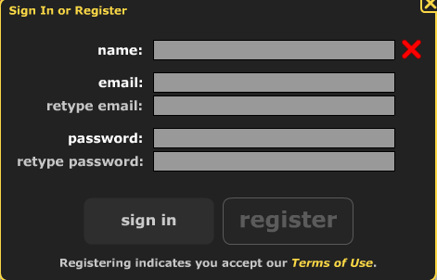

Classroom teachers using Voicethread often create one account for classroom use. This solves the challenge of asking students or families to sign up for personal accounts—and is important for middle and elementary teachers because Voicethread will not grant accounts to students less than 13 years of age.

After signing into Voicethread, teachers will want to create a collection of “identities” for students to use while commenting on Voicethread presentations. Identities allow students to identify themselves—as well as new comments—while participating in stranded conversations without revealing their true identities. This practice promotes responsible Internet safety practices in student users.

Be inventive with the identities that you create! Selecting interesting images lends a sense of personality to Voicethread presentations that middle grades students really enjoy.

To create identities, select My Account from under the Help menu:

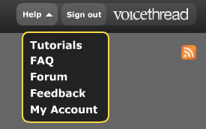

A list of identities that you have already created will appear. Select Add an Identity from the bottom of this list:
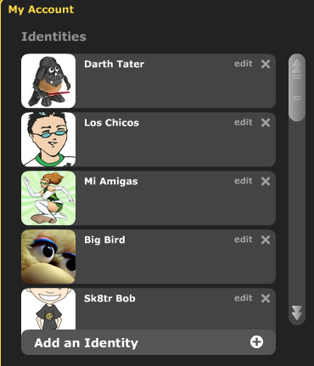

Enter a name and then upload an image for your new identity. Then, select Save. Your new identity will be added to the list of identities that you’ve already created:
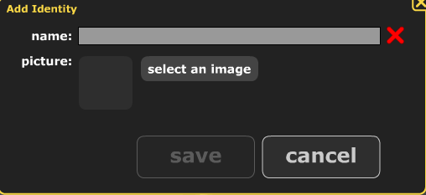

Planning a Voicethread
Once you’ve created an account and a collection of identities for students to use while commenting on a Voicethread, it’s time to create your first presentation. Begin by carefully selecting a topic that will promote conversation and debate between students—and that can be conveyed through images currently available to you.

Possible topics include:

What can you learn about the values of a country or a culture by studying images?
Is Global Warming having an impact on our world?
Has urbanization helped or harmed our community?
Where can evidence of math be found in our daily lives?
Is graffiti a form of artistic expression or simply vandalism?
Who are heroes?

After collecting a series of images that represent your topic, carefully script out short opening comments for each image that include a question for viewers to consider. Scripting comments prior to recording will allow you to organize your thinking—and your images—in a logical order. This early organization will save time as you produce your final product.

Initial comments should be somewhere between 1 and 3 sentences long. Longer comments will discourage viewers from adding their own thoughts—and tend to bore viewers quickly! Remember that your goal is to promote conversation, not to lecture through pictures. If you find yourself recording longer initial comments, you probably have images that aren’t very interesting.

Consider this sample comment, taken from the Denmark Voicethread referenced in the opening of this training guide:

“What do you notice in this picture taken outside the train station in Copenhagen—the capital of Denmark?”
Uploading and Organizing Images
Once you have finished creating a script for your images, select Upload from beneath the Create tab in your Voicethread account:
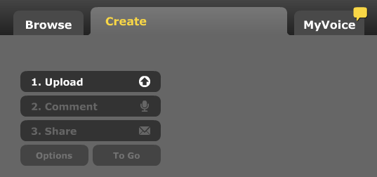

Then, select the location where the images for your Voicethread presentation are currently stored:


After selecting your images, Voicethread will automatically add them to a working window for your current presentation. From this window, you will arrange your images in a logical order and add titles or weblinks to individual images:
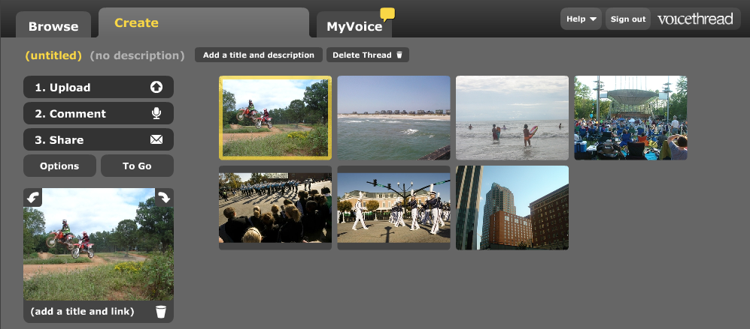

To manipulate an individual image in your presentation, click on it in your working window. A yellow frame will appear around the selected image, and a thumbnail will appear in the bottom left hand corner of the working window:

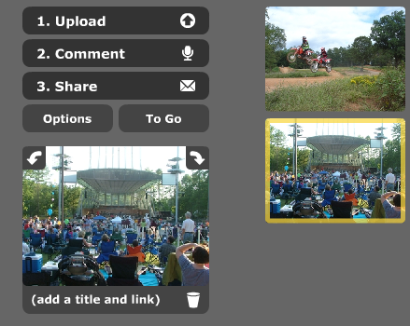
Images bordered by a yellow frame can be repositioned in your presentation by left-clicking and dragging to a new location.

By selecting Add a Title and Link beneath the thumbnail of your chosen image, you can add both a title and an external weblink to each picture that will be visible in your final presentation.

To finalize your initial presentation, select Add a Title and Description from the top of the working window to name your Voicethread and to add a narrative that will make your work stand out in the Voicethread catalog.
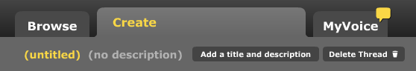

Recording Audio Comments
After uploading and organizing the images for your Voicethread presentation, you’re ready to begin adding audio and text comments. While either type of comment is acceptable, encourage your students to add audio comments—which tend to be more engaging and easier to follow. Hearing voices of other users also adds a sense of personality to presentations!

To add audio comments to your presentation, begin by selecting the Comment button from the main working window toolbar:

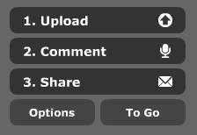

Your first image will appear above a commenting toolbar:
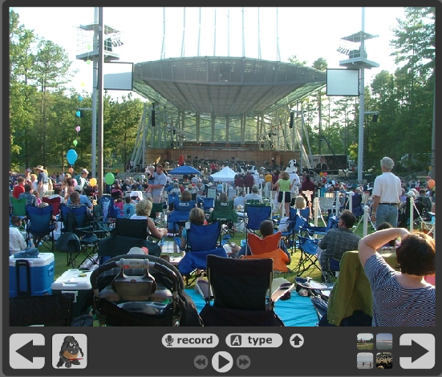

To add an audio comment, select the Record button found in the commenting toolbar at the bottom of your image. The first time that you insert an audio comment, you will be asked to give Voicethread access to your microphone:


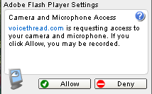

When you are finished recording your audio comment, select Stop Recording:


Your recorded comment will then be played back for your approval. If you are satisfied with its quality, select Save. If you’d like to re-record, select Cancel:


Each new comment is identified by an icon in the sidebar of the image. When a comment is being played, a speech bubble appears above the icon of the identity that added the comment:
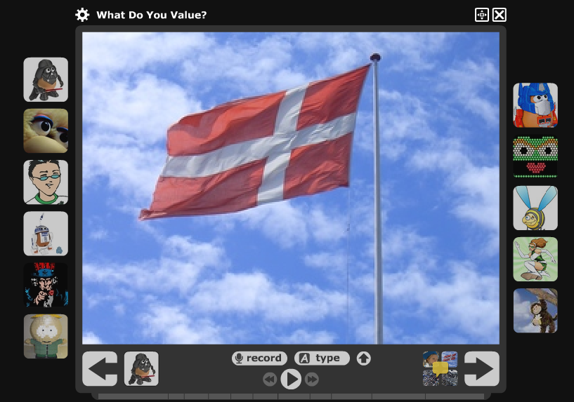
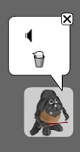

Recording Text Comments
While audio comments are generally far more engaging than text comments, many teachers and students feel uncomfortable recording their own voices! For these users, text comments may be more appropriate. To add a text comment, select Type from the commenting toolbar at the bottom of each image:

After selecting Type, a speech bubble will appear above the icon representing the identity of the commenter. Begin typing a written comment into the speech bubble and then select Save from the commenting toolbar. Your comment will automatically be added to the image—and your icon will appear in the sidebar:
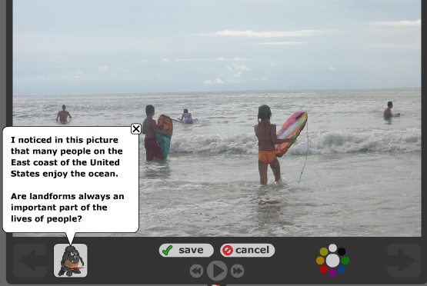

Switching Identities
When adding comments to an image that other users have already visited, it is important to select a new identity to make your comment stand out as unique. To switch identities, begin by clicking the identity icon found in the bottom left hand corner of the commenting toolbar:



You will be given a list of every identity associated with the Voicethread account that you have logged in with. Simply select an icon that hasn’t been used yet and begin recording:
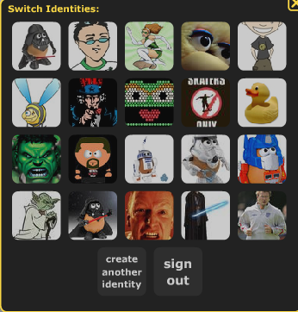

Navigating through a Presentation
There are two ways to navigate through a Voicethread presentation. First, you can use the block arrows found in the corners of the commenting toolbar to move through the Voicethread in sequential order:

You can also click on the thumbnail images found in the bottom right hand corner of the commenting toolbar to move through the Voicethread in a non-sequential order:


Commenting Tips for Voicethreaders
The best Voicethreads are truly interactive—with users listening and responding to one another. They are super interesting digital conversations! Highly accomplished Voicethreaders are constantly thinking while interacting with a Voicethread presentation. They come to the conversation with an open mind, willing to reconsider their own positions—and willing to challenge the notions of others.

Voicethreading requires users to develop the skills that active thinkers bring to any learning experience. Some of the best tips about active thinking have been developed over time by teachers like Kelly Gallagher and Matt Copeland—who have each written books about reading and writing in middle and high schools. They’ve also been developed by an organization called Project CRISS—Creating Independence through Student Owned Strategies.

The following tips for Voicethreaders are adapted from the collective work of Gallagher, Copeland and Project CRISS:

To be an active Voicethreader, start by carefully working your way through a presentation. While viewing pictures and listening to the comments that have been added by other users, you should:

- Gather Facts: Jot down things that are interesting and new to you

- Make Connections: Relate and compare things you are viewing and hearing to things that you already know.

- Ask Questions: What about the comments and presentation is confusing to you? What don’t you understand? How will you find the answer? Remember that there will ALWAYS be questions in an active thinker’s mind!

- Give Opinions: Make judgments about what you are viewing and hearing. Do you agree? Do you disagree? Like? Dislike? Do you support or oppose anything that you have heard or seen? Why?

Use the following sentence starters to shape your thoughts and comments while viewing or participating in Voicethread presentations. Comments based on these kinds of statements make Voicethreads interactive and engaging.

- This reminds me of…
- This is similar to…
- I wonder…
- I realized…
- I noticed…
- You can relate this to…
- I’d like to know…
- I’m surprised that…
- If I were ________, I would ______________
- If __________ then ___________
- Although it seems…
- I’m not sure that…

While commenting, try to respond directly to other viewers. Begin by quoting some part of the comment that you are responding to help other listeners know what it is that has caught your attention. Then, explain your own thinking in a few short sentences. Elaboration is important when you’re trying to make a point. Finally, finish your comment with a question that other listeners can reply to. Questions help to keep digital conversations going!

When responding to another viewer, don’t be afraid to disagree with something that they have said. Challenging the thinking of another viewer will help them to reconsider their own thinking—and will force you to be able to explain yours! Just be sure to disagree agreeably—impolite people are rarely influential.

If your thinking gets challenged by another viewer in a Voicethread, don’t be offended. Listen to your peers, consider their positions and decide whether or not you agree with them. You might discover that they’ve got good ideas you hadn’t thought about. Either way, be sure to respond—let your challengers know how their ideas have influenced you.

Here’s a sample comment from a Voicethread exploring landforms:

I’m not sure that I agree with Darth Tater when he says that oceans are the best landform to live near. After all, oceans cannot be enjoyed year-round. In the winter, they’re too cold to swim in.

To me, the best landform to live near would be one that could be used year-round. Can anyone think of landforms that are enjoyable in the spring, summer, winter and fall?

Sources Cited:

Copeland, M (2005). Socratic circles: Fostering critical and creative thinking in middle and high school. Portland, ME: Stenhouse.

Gallagher, K (2004). Deeper reading: Comprehending Challenging Texts 4-12. Portland, ME: Stenhouse.

Shanta, C (Ed.). (2007). Project CRISS training manual. Kalispell, MT: Project CRISS.

